

**100 Minute Stopwatch with Multiplexing and Persistence of Vision Display**

CPE 412N Digital Machine Design

1:30 – 4:30 TTH

Submitted by:

Diez, Christian Raymond IV J.

Lim, Gian Christian L.

Mendola, Princess Dianne D.

Tan, Jezreel V.

On December 11, 2018

**Project Description**

This project is a 100-minute stopwatch with a MM:SS display. It will continue to increment every second once activated through the asynchronous start-stop button and stopped by the same external input. Once the timer reaches 99:59, it will reset back to 00:00 and continue counting up. The timer can also be restarted by another asynchronous push button called restart. The restart button can only be activated once the timer is not moving to prevent any unwanted accidental restarts. The stopwatch is connected to four 7-segment displays with a common data input lines thus, employing multiplexing and persistence of vision. This project needs to be turned on primarily to allow other features to work.

**FSM**

***Mealy State Diagram for the stopwatch timer system as a whole***

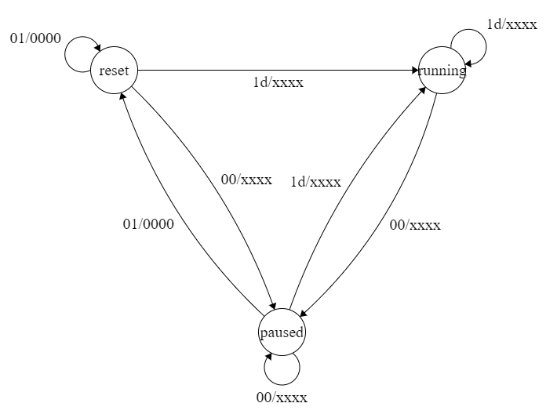

Input: Start & Reset (d is for don’t care)  
Output: 7 Segments (x because they change value depending on the time)

***Moore State Diagram for the 7 segment display employing persistence of vision***

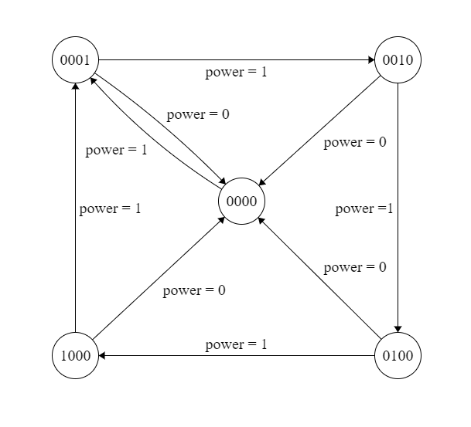

*\*1 means that the segment is on*

**Test Cases**

|  |  |  |  |
| --- | --- | --- | --- |
| **Test Inputs** | | | **Outputs** |
| **Power Button** | **Start-Stop Pushbutton** | **Restart Pushbutton** | **7-Segment Display Counter** |
| 1 | 0 | 0 | Stopwatch does not count up. |
| 1 | 0 | 1 | All outputs in the stopwatch resets to 0. Display turns 00:00. |
| 1 | 1 | 0 | Stopwatch counts up. |
| 1 | 1 | 1 | Stopwatch continues counting up ignoring the restart button input. |
| 0 | dc | dc | Systems turns off, nothing happens |

*\*dc is for don’t care*

**Main Module Code**

**Testbench Code**

*\*attached at next pages*

**GTK Wave Images**